Support System Features
Shawky

SADAD Features

Simple and fast Tracing of the problem

Example: Path =Crystal/Payment Statistics

Convert Statistics to Linked Charts

More easy and readable way for SADAD XML messages
SADAD xml messages have been parsed and displayed in a more readable and familiar way.

Example 1: Path = Crystal/Documents in sfs/Banks/ Bank All Recon Messages
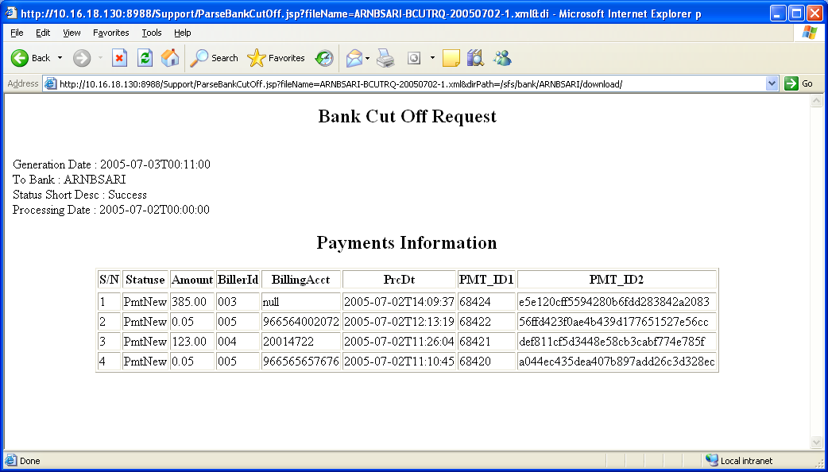
Bank Cut Off Message

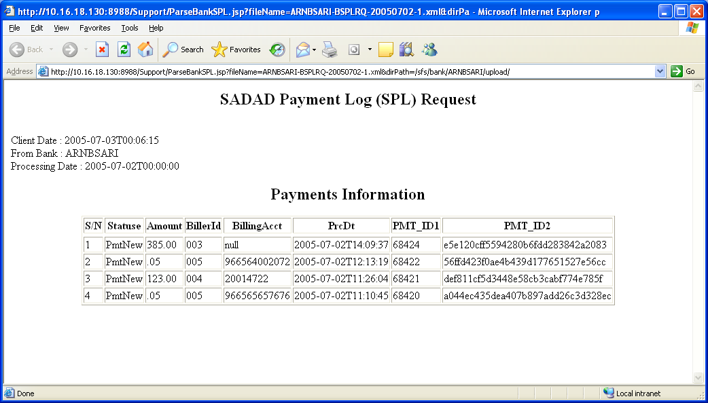
Bank SPL Message
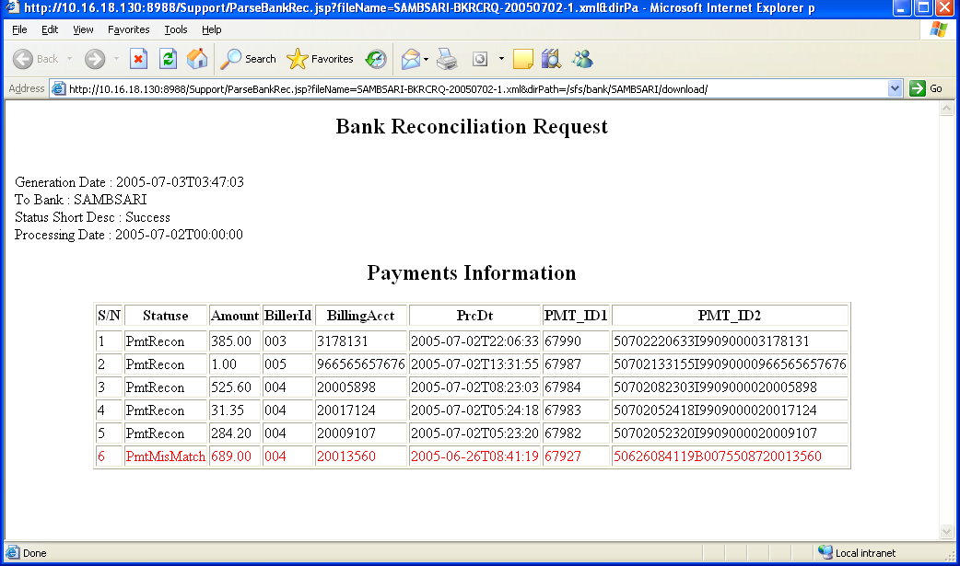
Bank Reconciliation Message

Example 2: crystal/ Settlement Process/ Intra Bank/ Bank XADDRQ

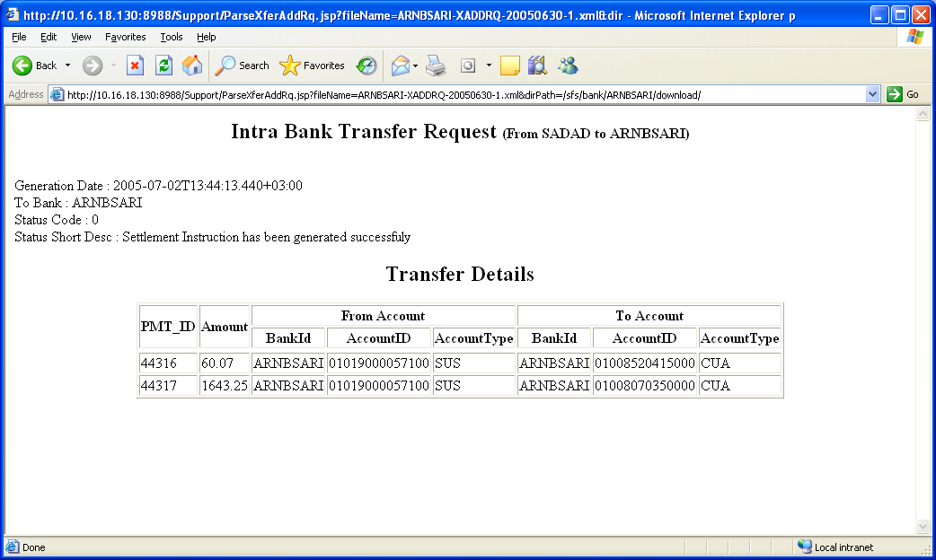
Bank XADDRQ Message

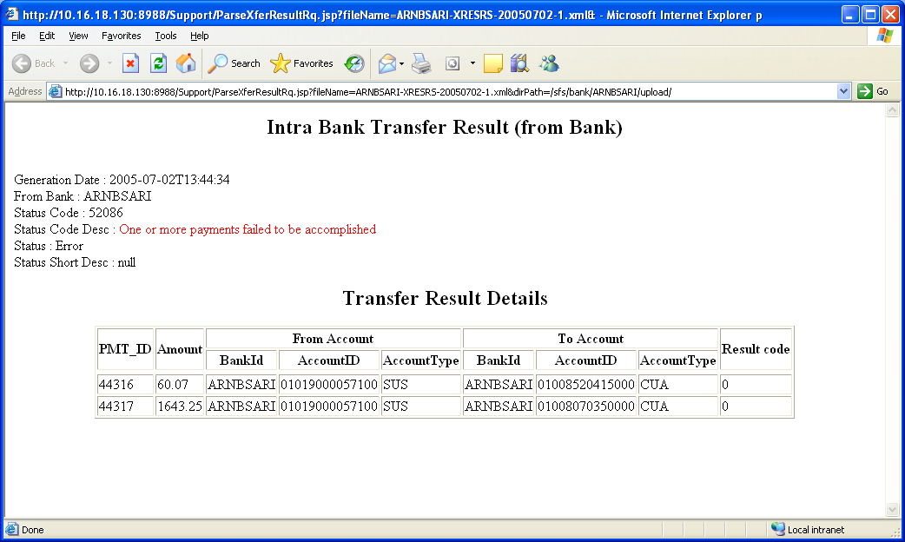
Bank XRESRQ Message

Automatic Mail Notifiation
This feature enable automatic mail notification containing any query result.

Using any batch file contains the following command

D:\dev10g\jdk\bin\java.exe -ojvm -classpath D:\MyWork\NCCI\classes;D:\dev10g\jdbc\lib\classes12.jar;D:\dev10g\jdbc\lib\nls_charset12.jar;D:\dev10g\j2ee\home\lib\activation.jar;D:\dev10g\j2ee\home\lib\ejb.jar;D:\dev10g\j2ee\home\lib\jaas.jar;D:\dev10g\j2ee\home\lib\jaxp.jar;D:\dev10g\j2ee\home\lib\jcert.jar;D:\dev10g\j2ee\home\lib\jdbc.jar;D:\dev10g\j2ee\home\lib\jms.jar;D:\dev10g\j2ee\home\lib\jndi.jar;D:\dev10g\j2ee\home\lib\jnet.jar;D:\dev10g\j2ee\home\lib\jsse.jar;D:\dev10g\j2ee\home\lib\jta.jar;D:\dev10g\j2ee\home\lib\mail.jar;D:\dev10g\j2ee\home\lib\servlet.jar;D:\dev10g\BC4J\lib\bc4jhtml.jar;D:\dev10g\BC4J\lib\datatags.jar;D:\dev10g\BC4J\lib\bc4juixtags.jar;D:\dev10g\BC4J\lib\bc4j_jclient_common.jar;D:\dev10g\j2ee\home\lib\ojsp.jar;D:\dev10g\j2ee\home\jsp\lib\taglib\ojsputil.jar;D:\dev10g\j2ee\home\oc4j.jar;D:\dev10g\j2ee\home\lib\servlet.jar;D:\dev10g\jdev\lib\ojc.jar;D:\dev10g\j2ee\home\oc4j.jar;D:\dev10g\j2ee\home\lib\servlet.jar;D:\dev10g\classes;D:\dev10g\jdev\lib\jdev.jar;D:\dev10g\lib\xmlparserv2.jar;D:\dev10g\lib\xmlcomp.jar NCCI.DownLoads.URLContentMailSender sfoda@sadad.com,habuattia@sadad.com,halenezi@sadad.com,ealsafadi@sadad.com,sbadran@sadad.com Yesterday_Payments_Message_Statistics http://10.16.18.130:8988/Support/executeQuery.jsp id=3672 AutoLog=Y parm1 =parm1Vaue parm2=parm2value

Running this batch will cause query No 3672 to be executed with parameters parm1 =parm1Vaue parm2=parm2value …. and its results automatically sent to sfoda@sadad.com,habuattia@sadad.com,halenezi@sadad.com,ealsafadi@sadad.com,sbadran@sadad.com with a mail subject = Yesterday_Payments_Message_Statistics

Using MS scheduler this process can be scheduled to run periodically upon need.

Admin Features

Configure Connections to DB

Write Your Own Query.

Combine more than one query together

Define Your Own query bind variables

Organize Your Queries in a hierarchal tree.

Hyper Link Your Quires together

Update Your Query Result (require update permission)

Draw Charts for Your Quires

Link Charts together

Convert Your Query result to XML

Link Your Query to FTP file Reader

Security in the Support System

Upload XLS files to DB.

Parse SADAD Message in a readable format better than the XML

Parse XML files and Upload it To DB

